OFFICE OF THE PRINCIPAL, GOVT. P.G. COLLEGE RAJOURI
PRESS RELEASE
GOVT. P. G. COLLEGE RAJOURI ORGANIZES INTERNATIONAL YOGA DAY

Govt. P.G. College Rajouri today organized International yoga Day in the campus. The faculty members, students and non-teaching staff members participated in the programme. Different popular “Yoga exercises were performed by the participants. Principal of the College Dr. Javaid Ahmed Qazi in his address said that Yoga originated from India 5000 years ago and is now followed speedily by the rest of the world. 21st June every year was unanimously declared by the United National General Assembly as International Yoga Day. He further said that Yoga is not only a physical exercise but signifies spiritual and moral values. The programme was a part of NSS activities under the guidelines of NSS Programme Officer Dr. Naseem Ahmed, Department of Chemistry of the College. Prominent staff members present in the programme were Prof. H.S. Ishar, Prof. Mohd Farooq Mirza, Prof. Javed Mughal, Prof. Z.A. Mirza Staff Secretary, Prof. M. A. Dar, Prof. Assadullah Khan, Dr. Yashpal Sharma and others.

(Dr. J. A. Qazi)
Principal
Govt. P.G. College
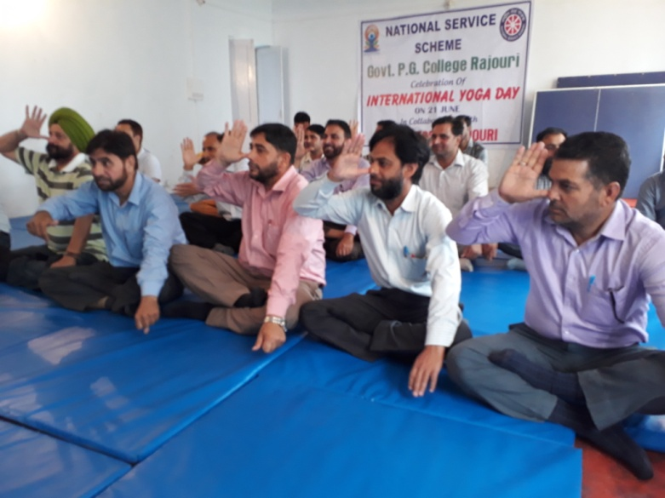
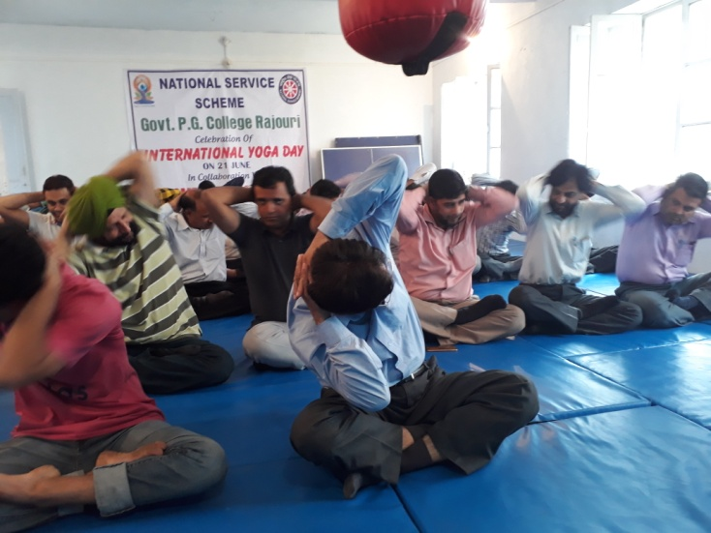
Rajouri

